
WINDOWS 7 SHREW VPN CLIENT
Instalation Manual

Version 1.0 | 10/28/2013
Author | Francisco Ramírez

Copyright © 2013Avantica Technologies
ALL RIGHTS RESERVED
Content

Content 2
Overview 3
Client computer requirements 3
Intallation Process 4
Execution Process 5

Overview
This guide describes how to configure and operate the Shrew Soft VPN Client with a Lucent Brick VPN Gateway. By tunneling traffic between the VPN Client and the VPN Gateway (Brick), the host is able to access private network resources in a manner which is secure even when connecting from an insecure public network.

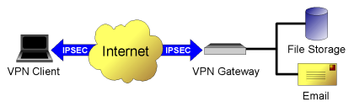

Client computer requirements

Windows 7 client
Tested on Windows 7 Professional "Version 64-bit"

Software requeriments
- Windows 7 Professional 64-bit

- Shrew Soft VPN client installer

Will be download from the following site:

https://www.shrew.net/download/vpn

o

\\192.168.1.248\installers\VPN Software

- VPN settings file (VPN Profile)
Ask the IT department with respect to the corresponding file.

Intallation Process

- Run the Shrew vpn-client-2.2.2-release file and doble click to install it.
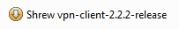

- Click in the Next button in the Welcome to the Shrew Soft VPN Client Setup Wizard screen, after that, use Standard Edition option and click Next .
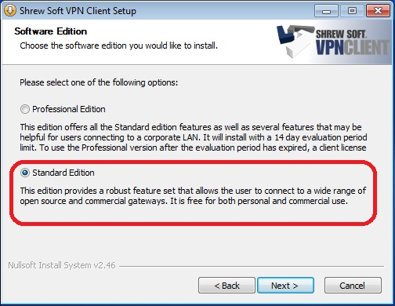

- Click in the I Agree button in the License Agreement screen, after that, click in the Next button, and click again in the Next button, after that, click in the Finis button.

Execution Process
- Double click in the VPN Access Manager icon 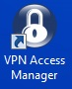 and go to File, Import and use the file with extension .vpn (Ex: Lucent Avantica SJO.vpn), click in the Open button in order to add the VPN profile.
- Select Lucent Avantica SJO.vpn icon 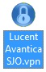 and click Connect 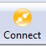

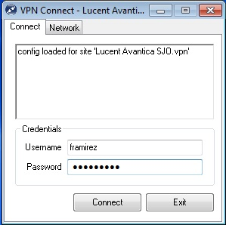
- Ensure that you are connected to Internet and writes your VPN credentials and click the Connect button to access the Avantica Network.

- Now you will be connected to the Avantica VPN.
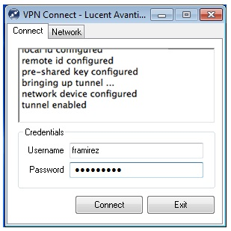

- Use cmd to check really the VPN connection.
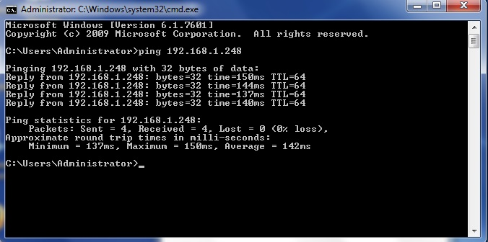

- Now, you can use Remote Desktop Connection to connect to your computer on Avantica, you need to use your IP Address

